National Standards for Physical Education

The goal of physical education is to develop physically literate individuals who have the knowledge, skills and confidence to enjoy a lifetime of healthful physical activity.

To pursue a lifetime of healthful physical activity, a physically literate individual:
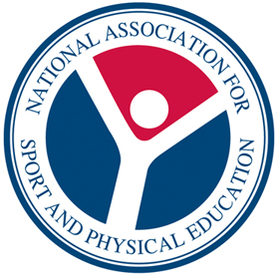
- Has learned the skills necessary to participate in a variety of physical activities.
- Knows the implications of and the benefits from involvement in various types of physical activities.
- Participates regularly in physical activity.
- Is physically fit.
- Values physical activity and its contributions to a healthful lifestyle.

Standard 1 | The physically literate individual demonstrates competency in a variety of motor skills and movement patterns.
Standard 2 | The physically literate individual applies knowledge of concepts, principles, strategies and tactics related to movement and performance.
Standard 3 | The physically literate individual demonstrates the knowledge and skills to achieve and maintain a health-enhancing level of physical activity and fitness.
Standard 4 | The physically literate individual exhibits responsible personal and social behavior that respects self and others.
Standard 5 | The physically literate individual recognizes the value of physical activity for health, enjoyment, challenge, self-expression and/or social interaction.

